Curriculum Vitae

Personal Data

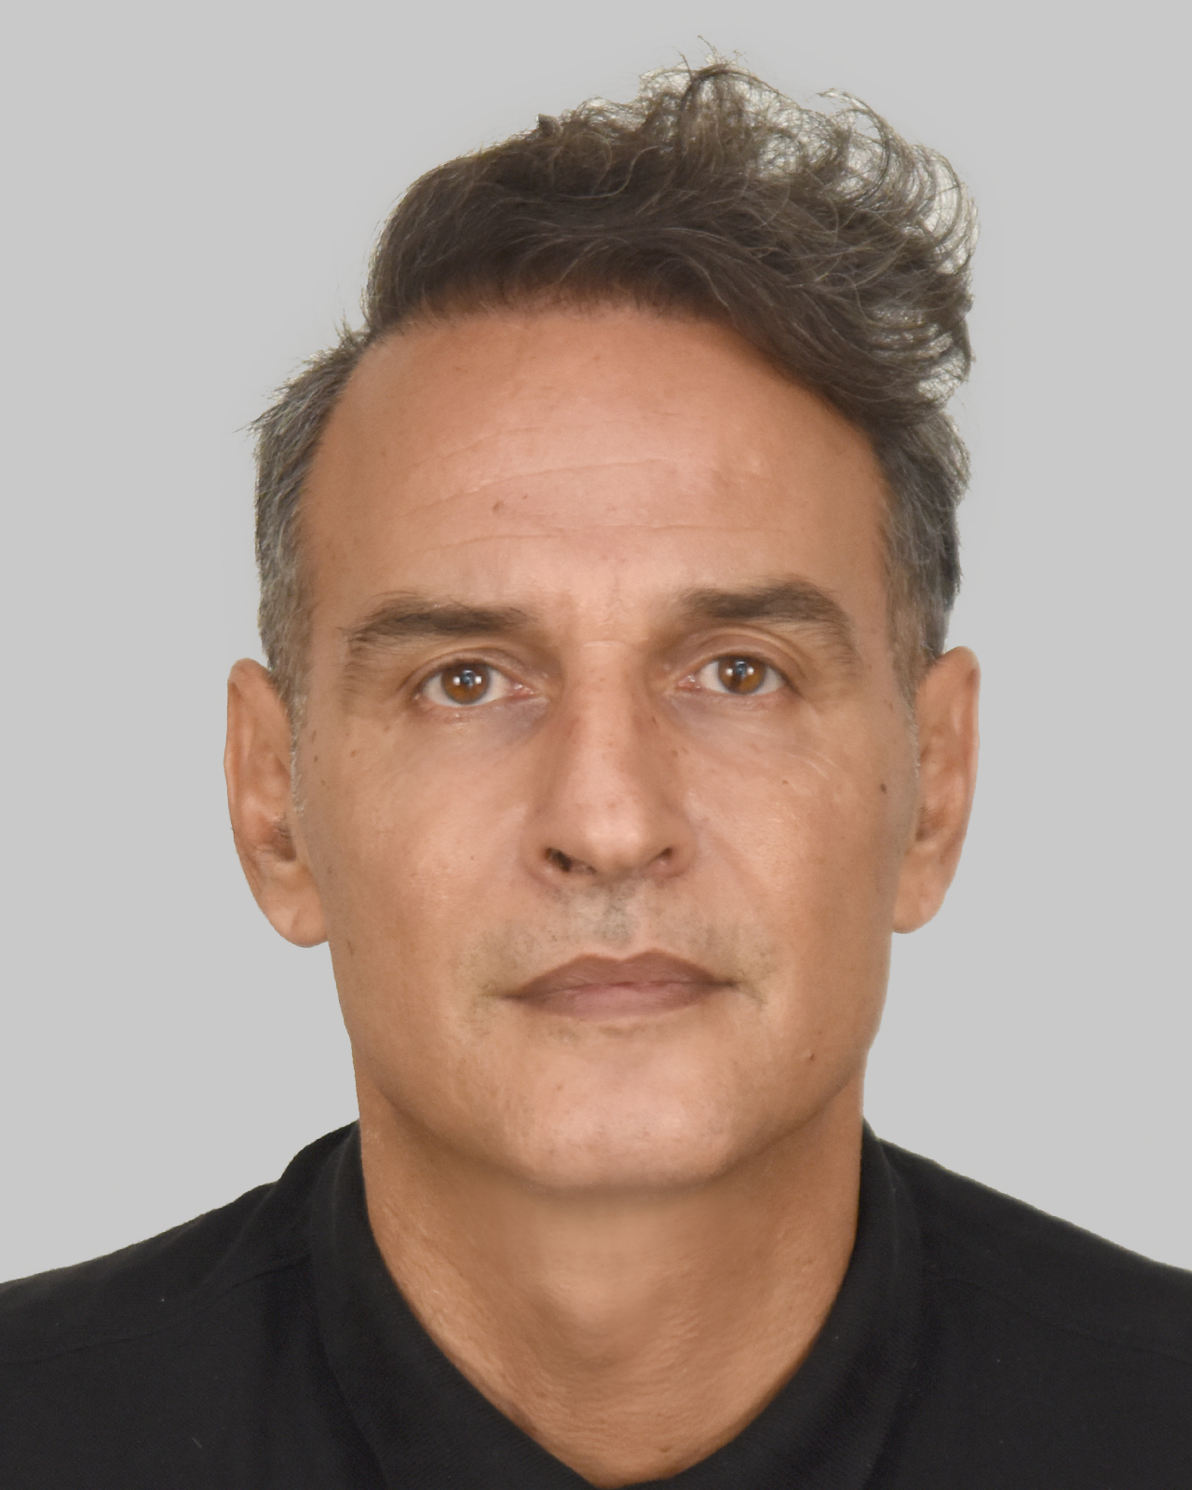 | Name | Kostas Koutsoumanis
 | Mail Address | Laboratory of Hygiene and Microbiology of Foods, Department of Food Science & Technology,  School of Agriculture, Aristotle University of Thessaloniki AUTh,  P.O. Box 256, Thessaloniki, Greece 540 06
 | Τel-Fax  e-mail | 0030 2310 991647  kkoutsou@agro.auth.gr

Summary

Kostas Koutsoumanis is currently serving as a Professor, Head of Laboratory of Food Microbiology and Hygiene and Head of the Department of Food Science and Technology in Aristotle University of Thessaloniki, Greece. He received his B.S. degree in Agriculture Engineering from the Agricultural University of Athens, Greece, in 1997 and Ph.D. (Food Science) degree from the same University in 2000. After serving as a Research Associate in the Department of Animal Sciences at Colorado State University he took a Lecturer position in the Department of Food Science and Technology at Aristotle University of Thessaloniki in 2002 and promoted to Assistant Professor in 2007, Associate Professor in 2013 and Professor in 2017. Currently, he teaches several graduate and MSc courses including General Microbiology, Food Quality and Safety Assurance, Predictive Microbiology and Risk Assessment and Applied Statistics in Food Science. From 2018 to 2024 he was the Chair of the Biohazard panel and from 2024 he is the vice-Chair of the Scientific Committee of the European Food Safety Authority (EFSA). From 2018, he is a member of Joint FAO/WHO Expert Meeting on Microbiological Risk Assessment (JEMRA) roster of experts. He is Associate editor in the journal Frontiers in Microbiology and member of the editorial boards of the Journal of Food Protection, International Journal of Food Microbiology, Food Microbiology and Current Opinion in Food Science. He has been invited to give opening and keynote lectures to more than 15 international scientific conferences and workshops. As a principal investigator or co-investigator, Kostas Koutsoumanis has received over 5 million euros in grants for research in the field of microbiological quality and safety of foods. His research is focused on the microbiology of foods including Predictive Microbiology, Microbial Risk Assessment, single cell microbiology, Antimicrobial Resistance (AMR) etc. Results from the above research have been published at more than 250 refereed scientific journal articles, 15 book chapters, and 150 papers in conference proceedings with more than 13500 citations and h-index=65.

